**Task Guideline**

Overview of Jira Team Space:

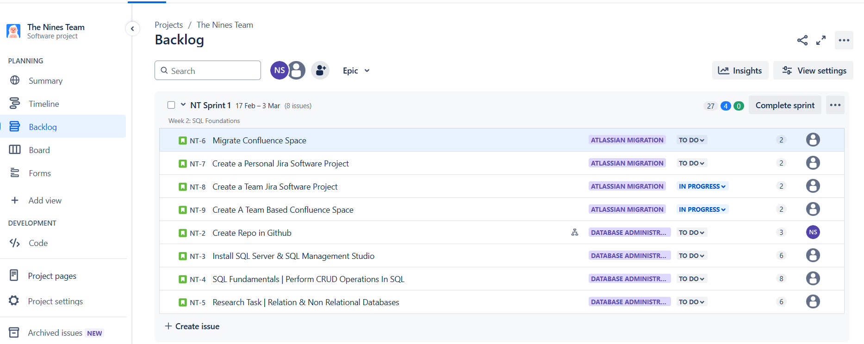

Migrate Confluence Space:

## **Description**

Migrate personal confluence space/content from the old directories/url to a directory which is named after your teams. the directory names are always prefixed ‘sambe-teamname’  
  
Please note the space you are moving your content to is still a personal space.

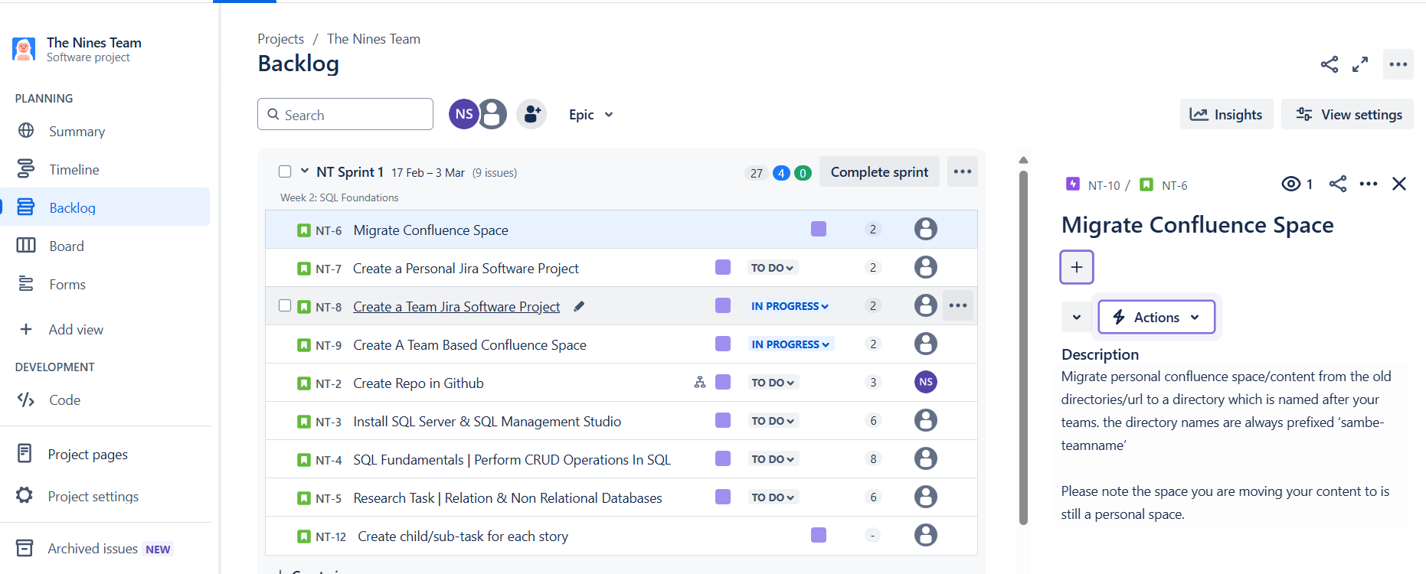

Create a Personal Jira Software Project (Pease include your own description):

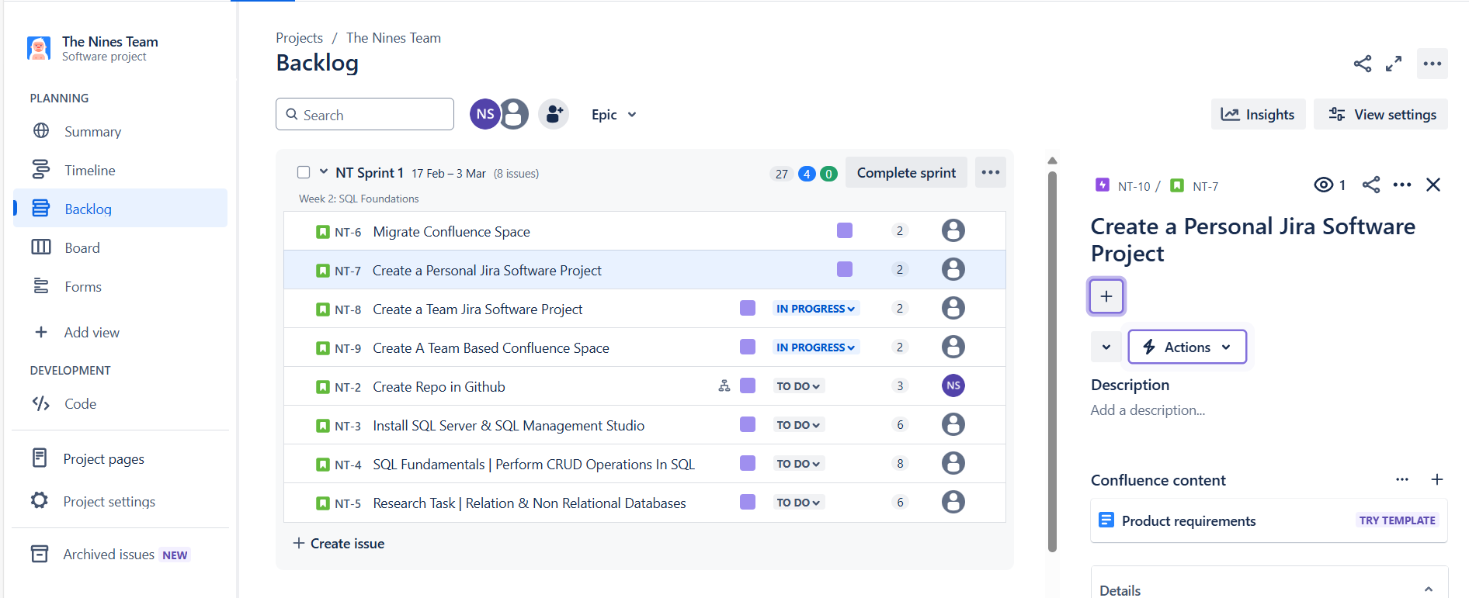

Create a Team Jira Software Project (Pease include your own description):

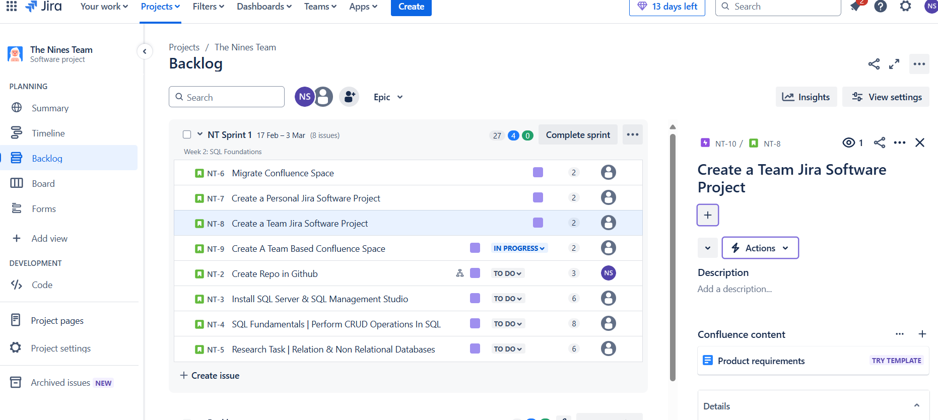

Create a Team Based Confluence Space (Pease include your own description):

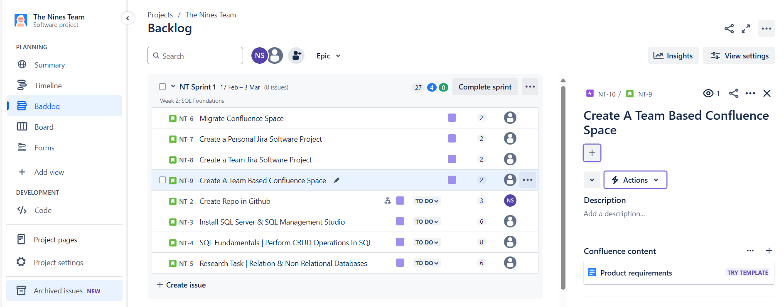

Create Repo in GitHub:

## **Description**

Github Tasks

1. Create a Repo in Github inside the organization named ; **sc_grads**. and name it using the following syntax;

* *sc_FirstNameLastname_Year*
* e.g ***sc_NeoMotaung_2025***

1. Create a Folder inside the repo and name it ”**DatabaseAdministration**”.
2. Create a Subfolder within the folder above and name it [**SQLStatements**](http://sqlstatements.in/) **this i where your are going to store your SQL scripts pertaining CRUD Operations**
3. Pull the repo to your local computer, on the local disk c location (C:\)

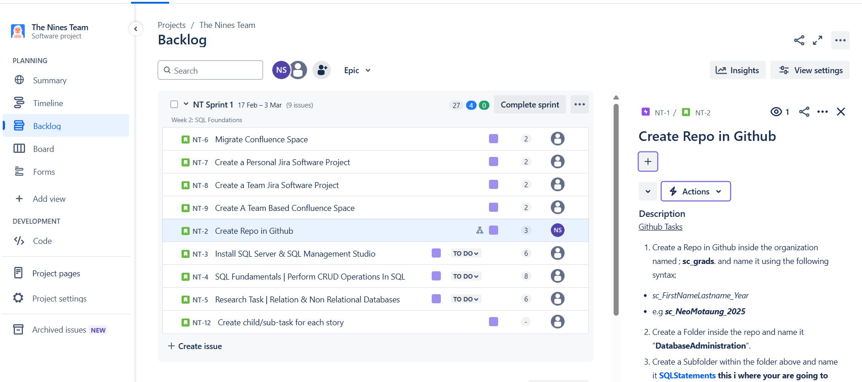

Install SQL Server & SQL Management Studio:

## **Description**

* Install SQL Server Developer Edition; [SQL Server Downloads | Microsoft](https://www.microsoft.com/en-us/sql-server/sql-server-downloads?msockid=01fed46fa2c861c72d5fc0dfa33560a3)
* Install SQL Server Management Studio.

Reference:

Guiding Tutorial ; [SQL Server Tutorial For Beginners | SQL Server Management Studio Install & Tips 2022](https://www.youtube.com/watch?v=8vTCyhDyRjg&list=PL82C6-O4XrHfZoh2ZH7-HCPyh9oHeYPnz)

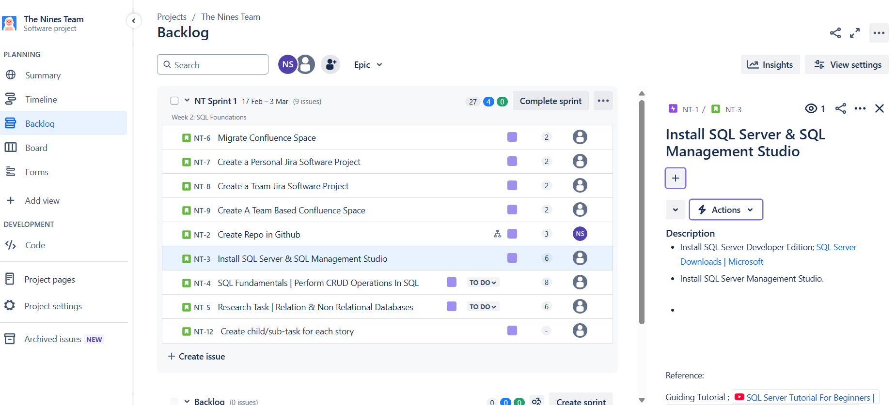

SQL Fundamentals Perform CRUD operations in SQL:

## **Description**

* Write Scripts in SSMS for each CRUD operation with comments also in the scripts.
  + SELECT
  + INSERT
  + UPDATE
  + DELETE
* These scripts must be stored in your SQLStatements subfolder which is already located in C:\   
  e.g. *C:\sc_FirstNameLastName_2025/DatabaseAdministration/SQLStatements*
* Remember to first create a database & table
  + CREATE DB
  + CREATE TABLE

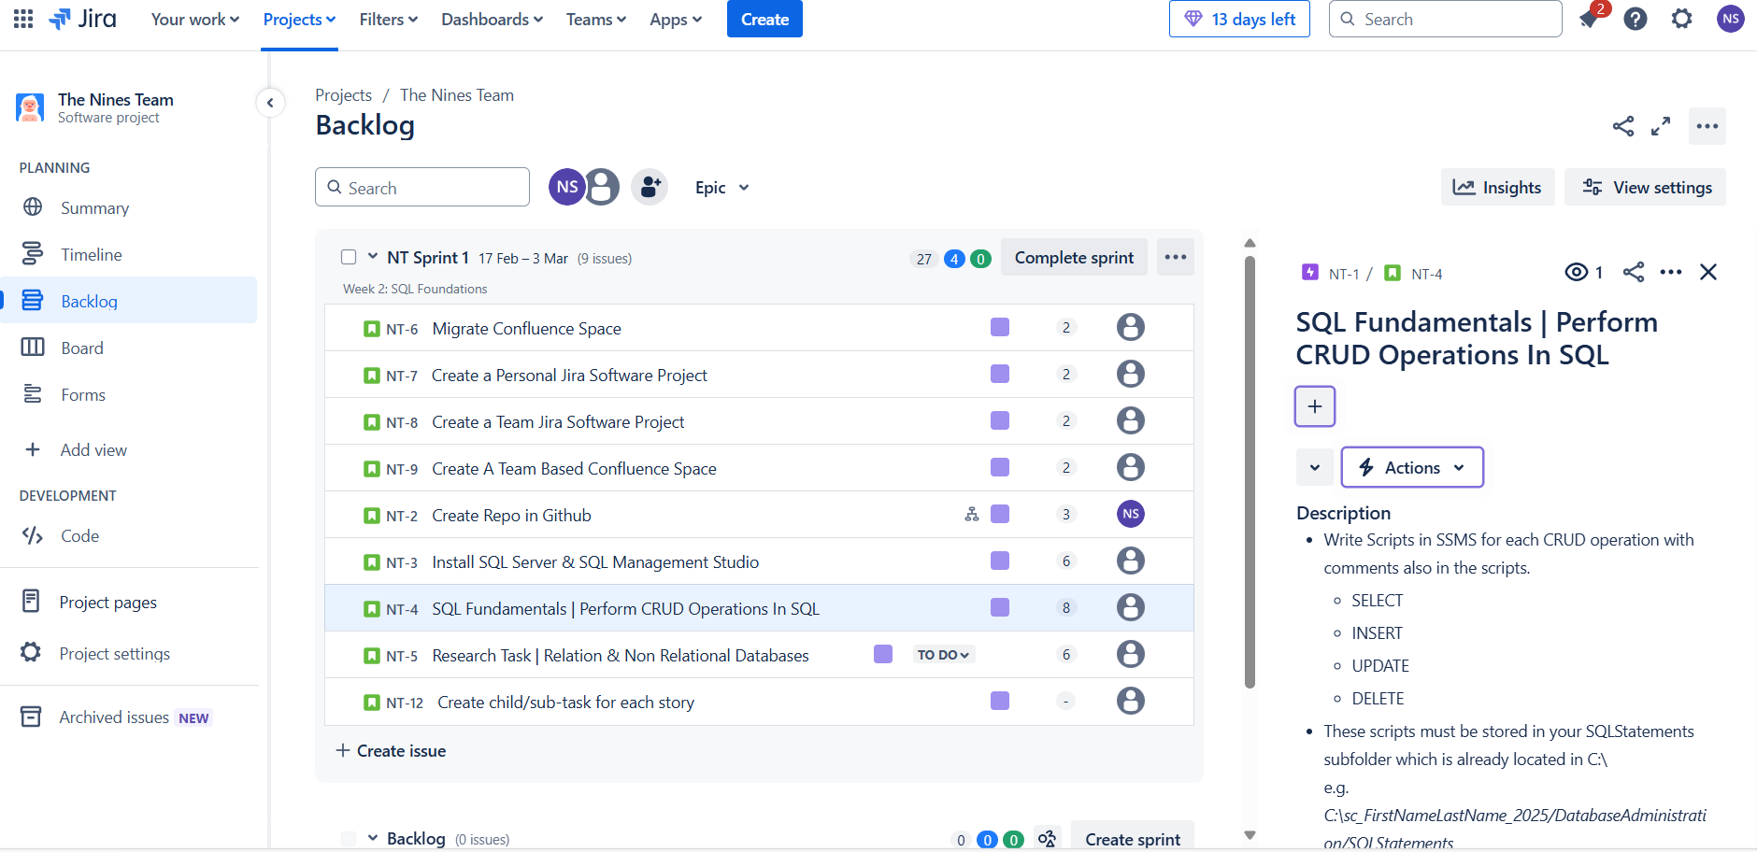

Research Task Relational & Non-relational Databases:

## **Description**

**Topics to Cover**

* Introduction to SQL vs NoSQL Databases (Relational vs Non Relational)
* Databases and Data Types
* Understanding Structured vs Unstructured Data
* OLAP vs OLTP
* ELT vs ETL

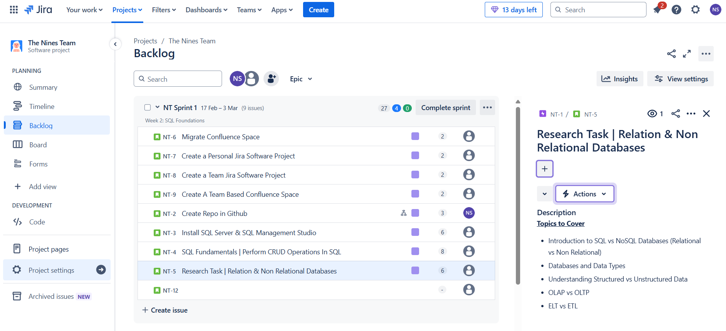

Create child/sub-task for each story:

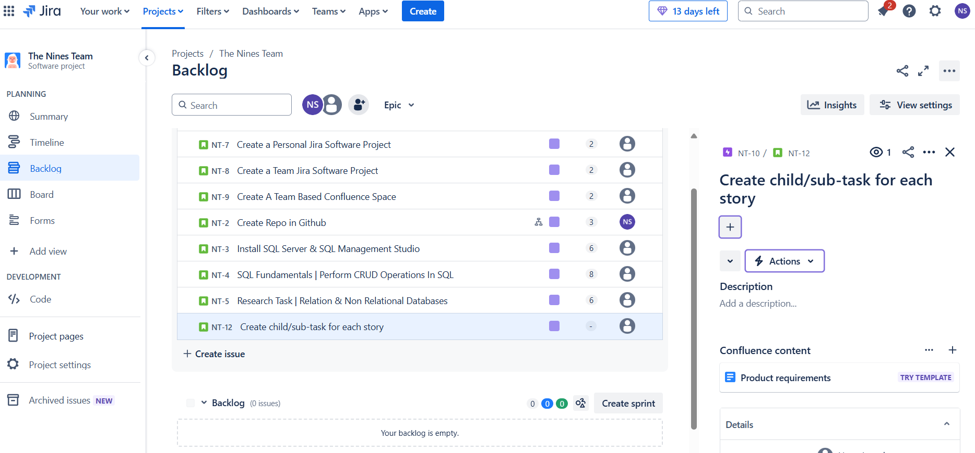

Timeline Overview:

